Pyracloud
Starting point = different dashboards in dropdown box
From within the dashboard user can drill down to details
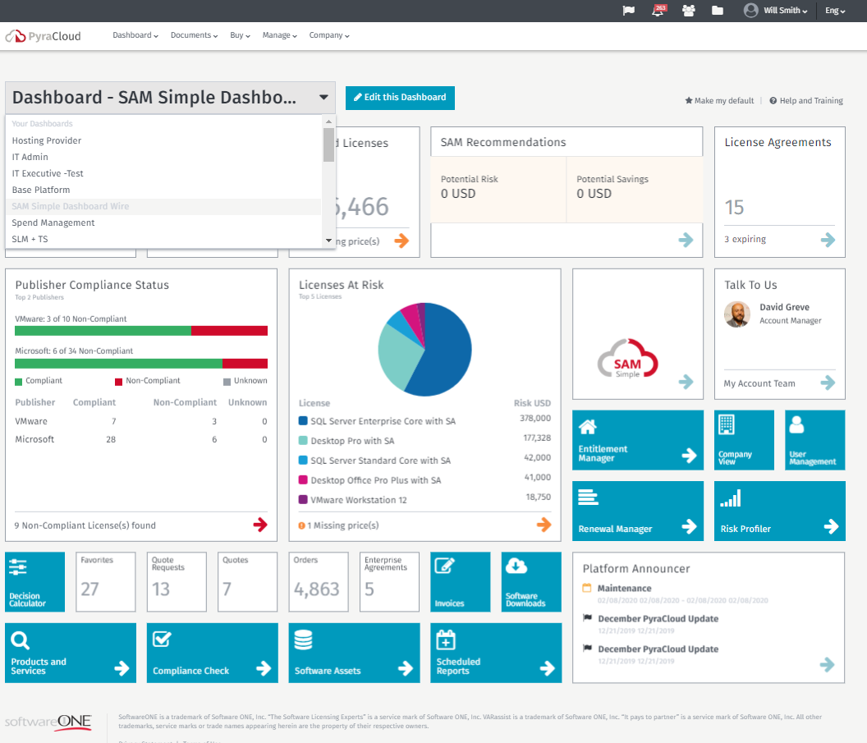
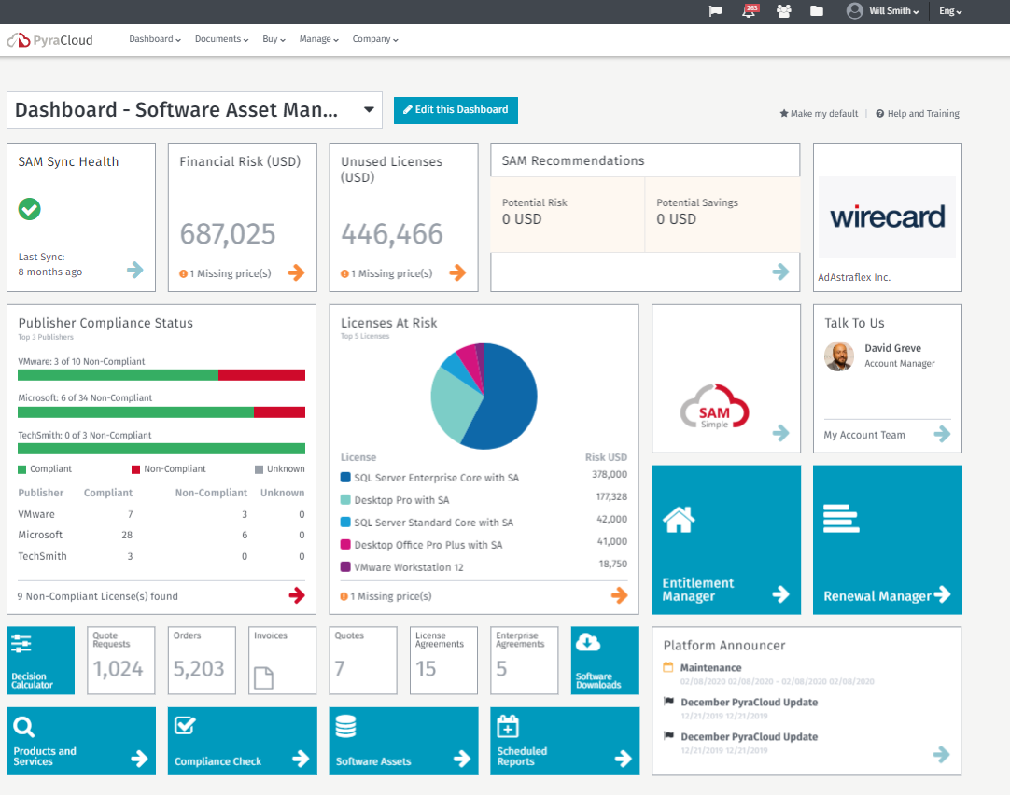
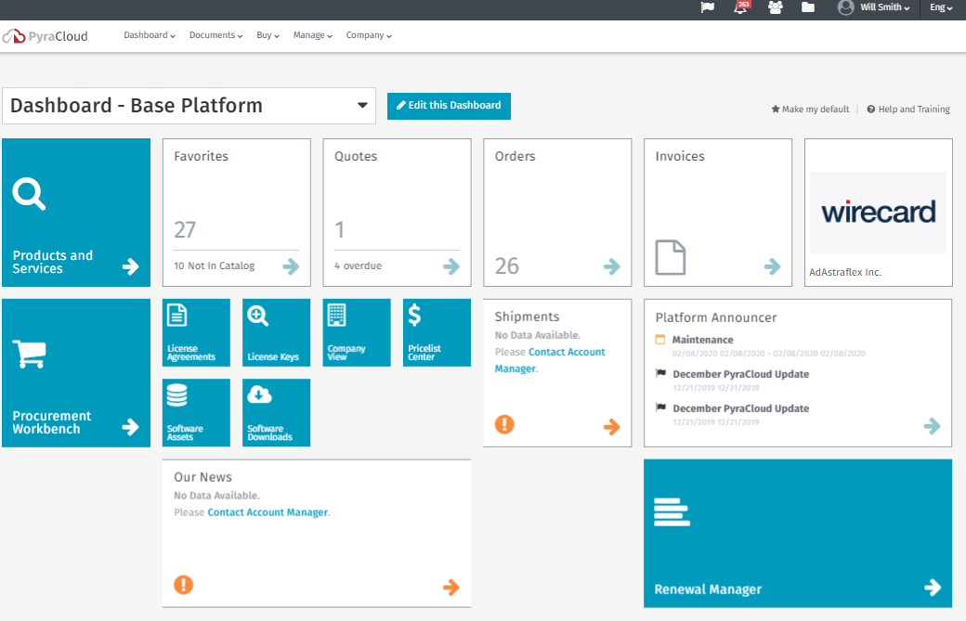
Menu Items on menu bar:
Menu bar options give direct access to specific details
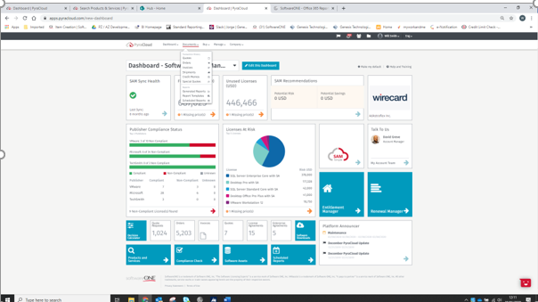
Notifications on platform maintenance (Flag on top)
Gives information on Maintenance Planning and New releases of the platform
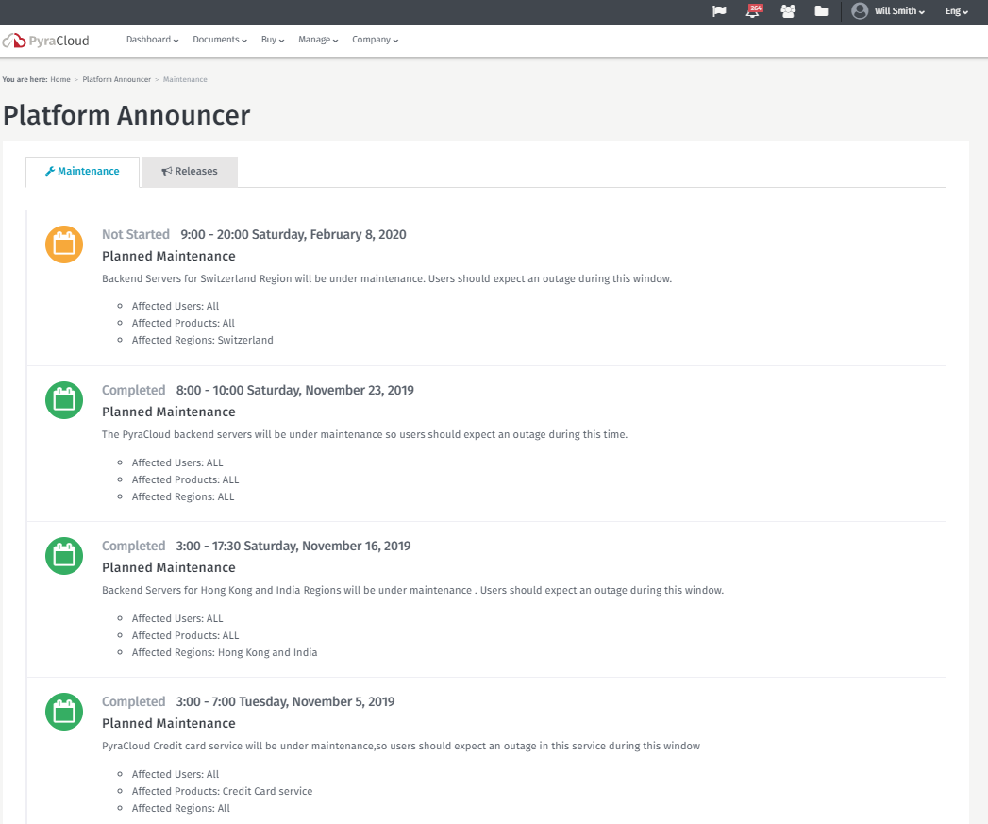

Easy Navigation (where I am )(click capable)
Clickpath is displayed to show you where you are. The path is clickable so you can go back to previous screens
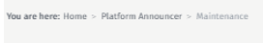
Personal Notifications (klok bovenaan)
Listing of personal notifications. Notifications are setup through the “Notification Manager”
In the side panel the most recent-unread notifications appear and can be changed to read (and disappear) by clicking on “Got it” button that appears when hoover over the notification.
When click on notification -> the Notification window is opened
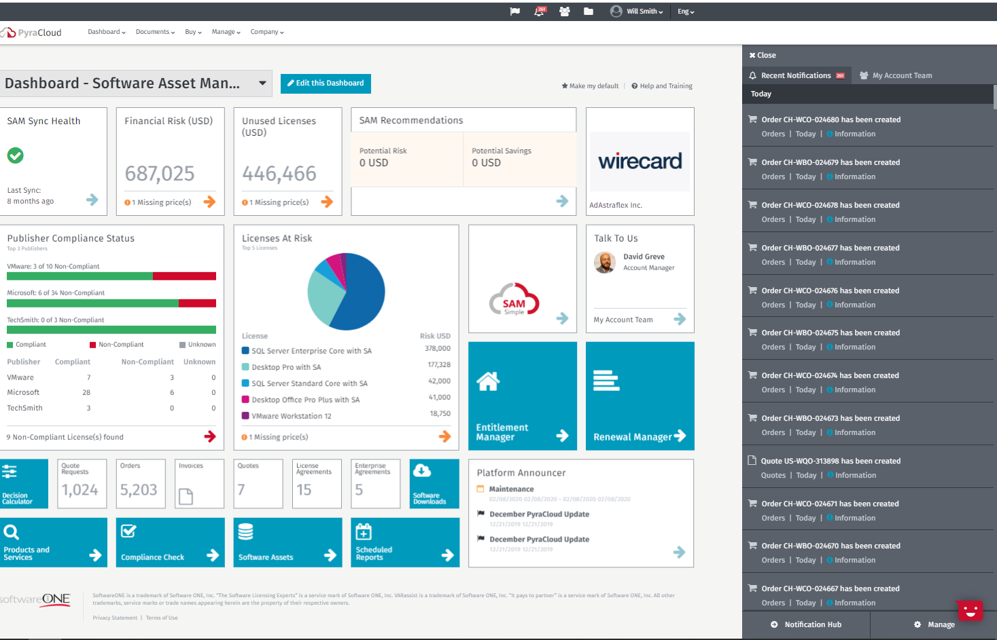
Ask for feedback
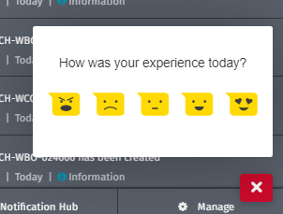

Notification Hub

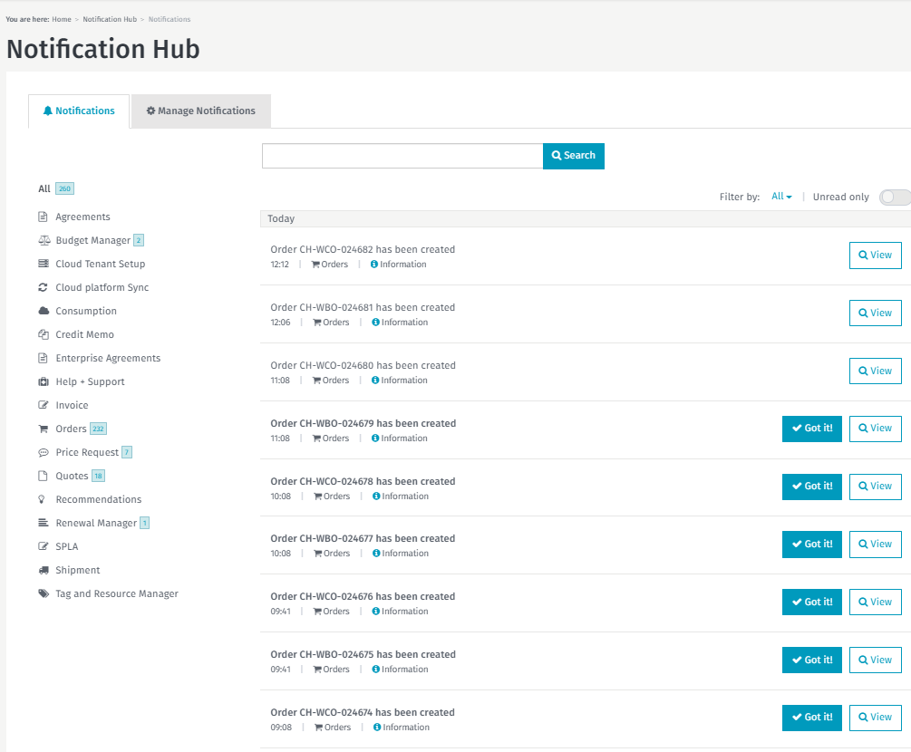

View
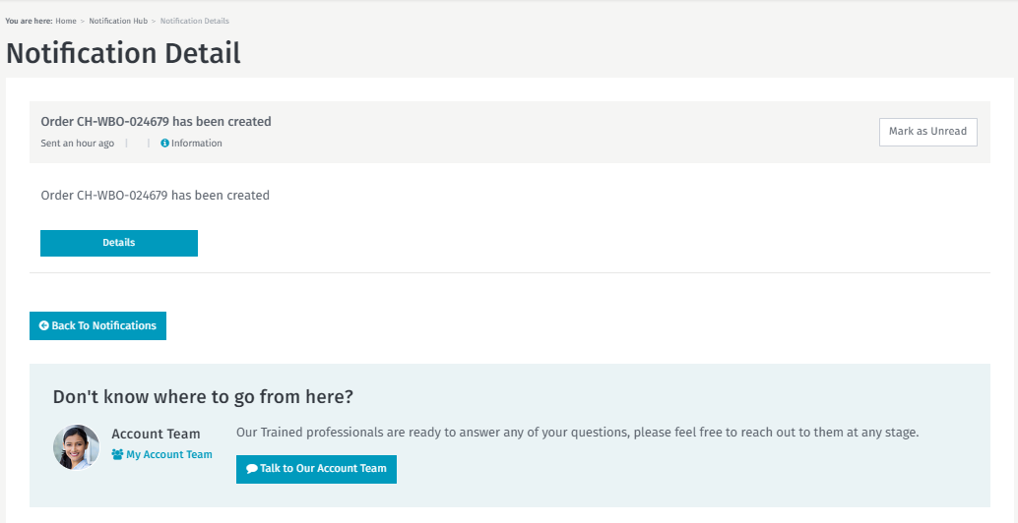

Manage notifications:
Rules can be put in place for notifications.
There are different types of notifications and for each notification type you can define when a notification should be displayed (v Web Notification) or send.
Sending can be done by mail or sms (what’s app?) . The mail address/phone is linked to person logged in.
If email or phone is missing -> user can add it (“Mobile number” button). The information entered is written to the user data.
Each notification has a label defining the type of notification (information , warning, error, critical). Notifications can be filtered on these labels.

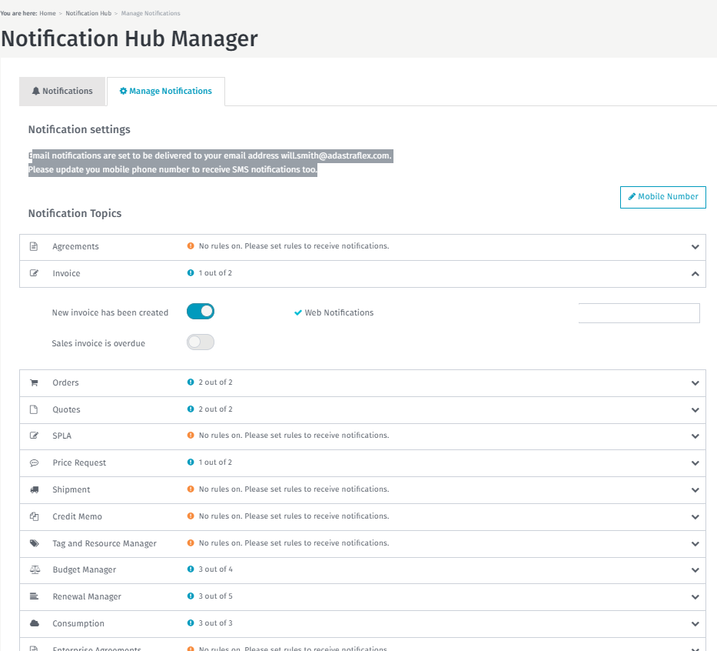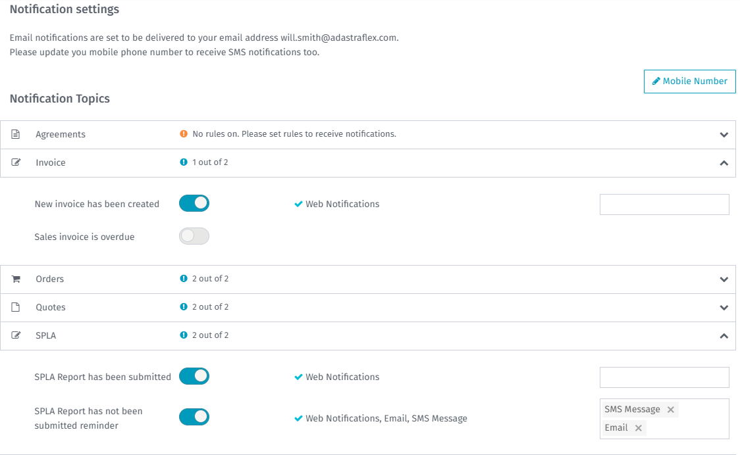

User profile
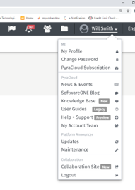
Support
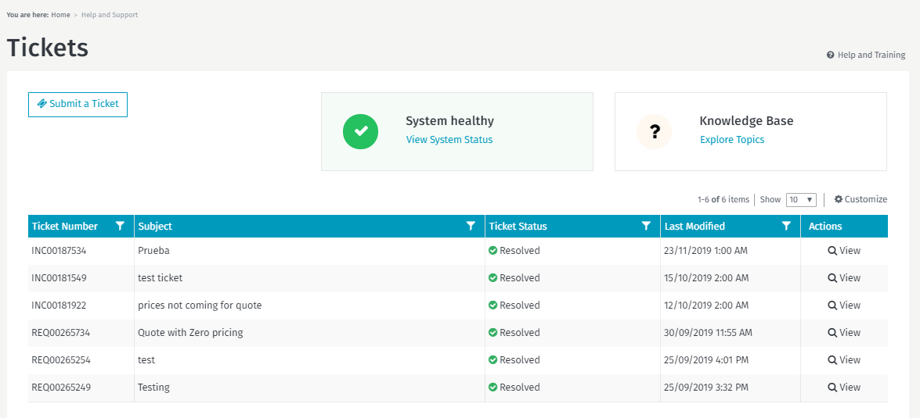
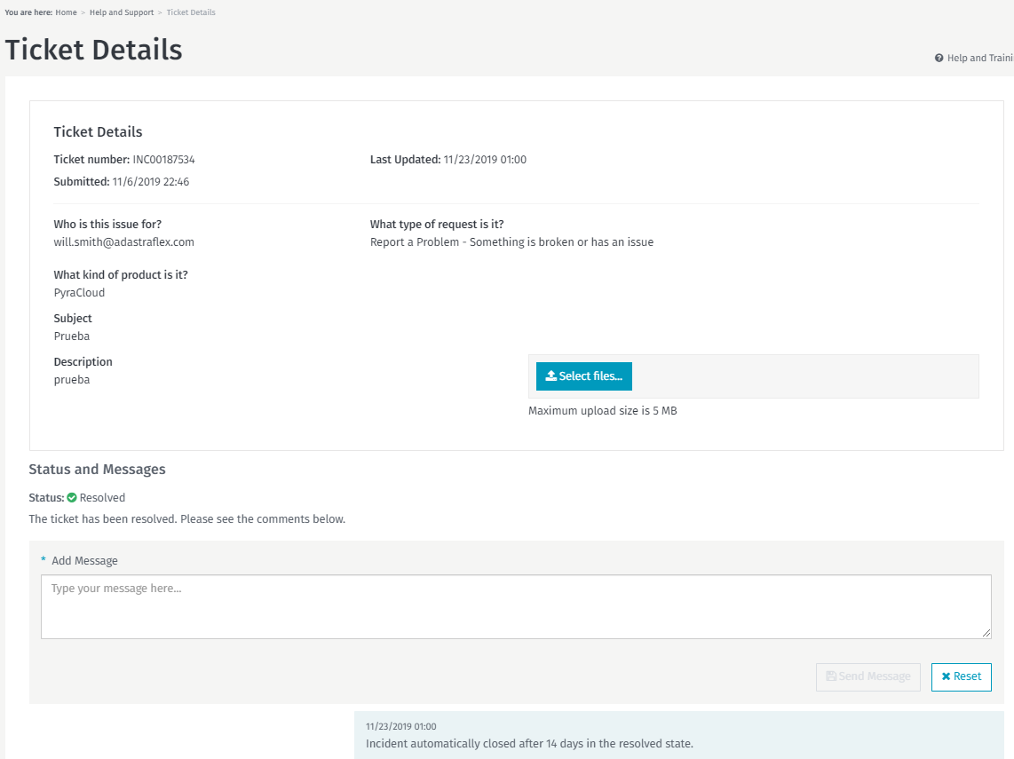

Knowledge base
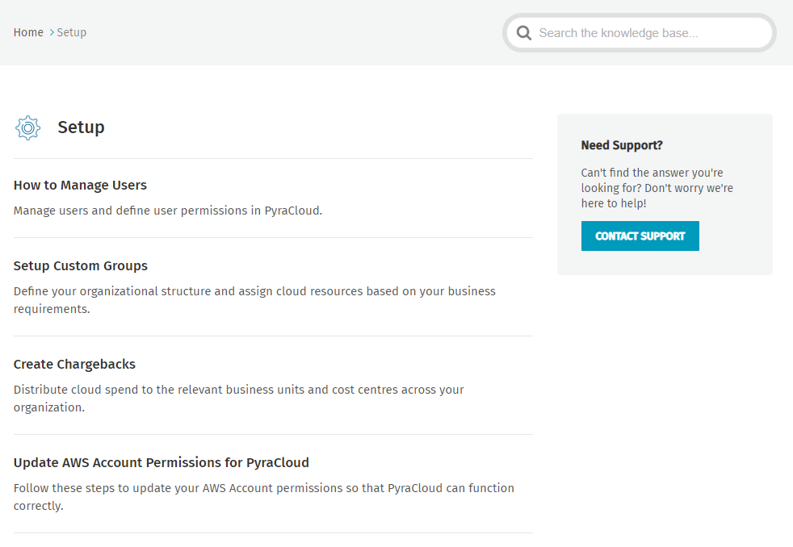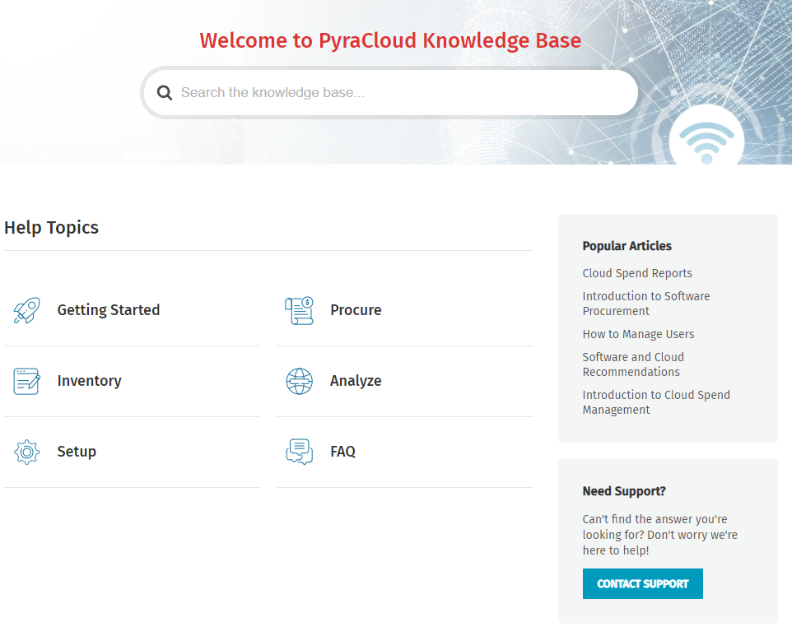

Knowledge base search

Suggestions are made while typing
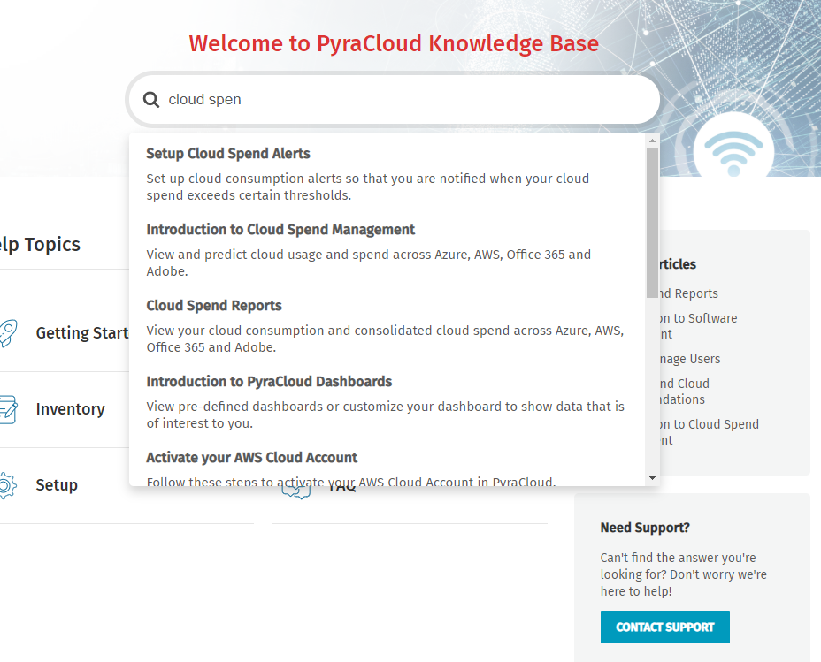
Help & Training (related tot he platform us
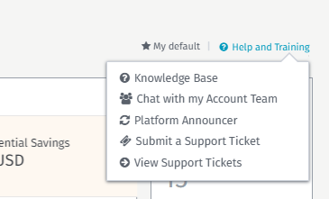

User Management (maybe use same for Comapany)
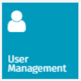
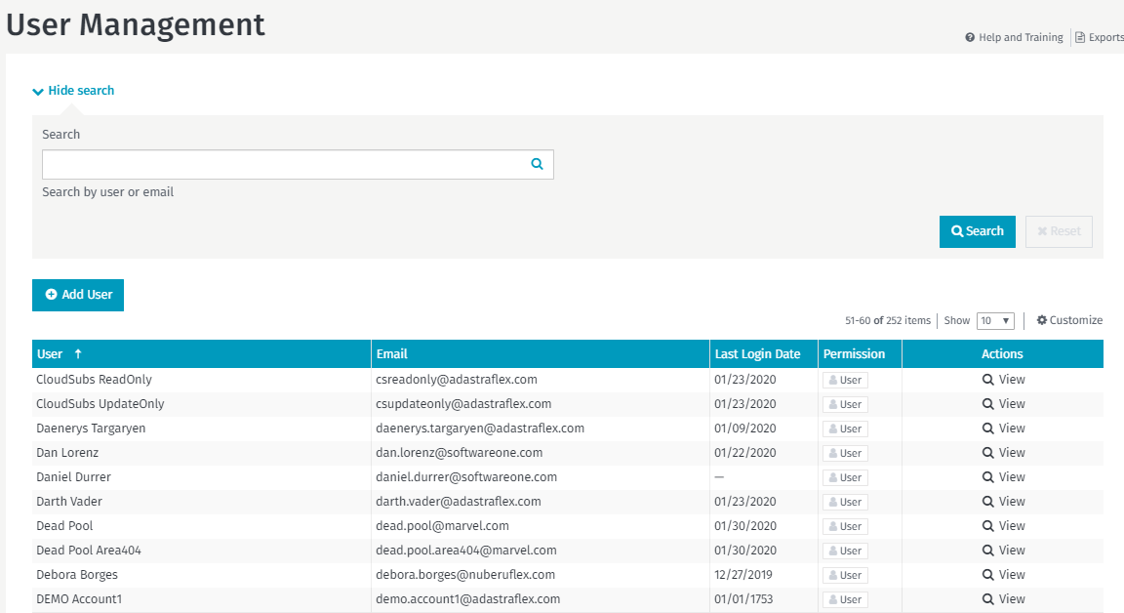
User detail
Multiple Tabs for multiple features linked to user

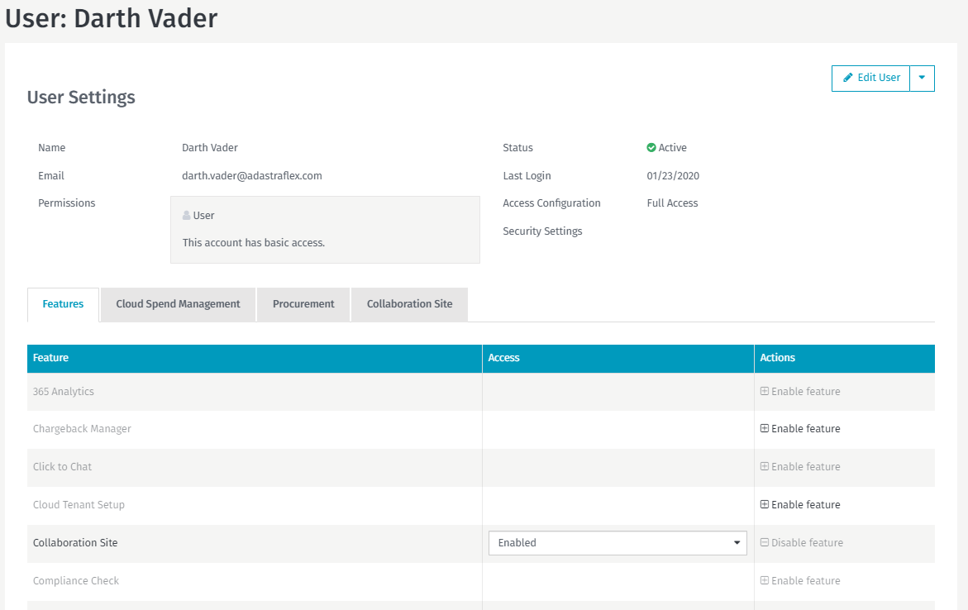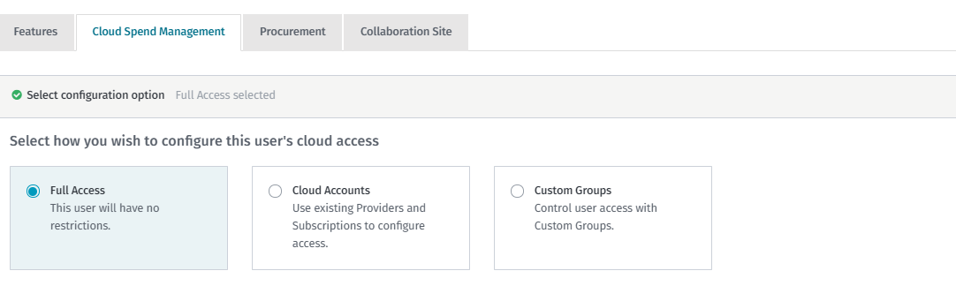

Detail views (example for orders)
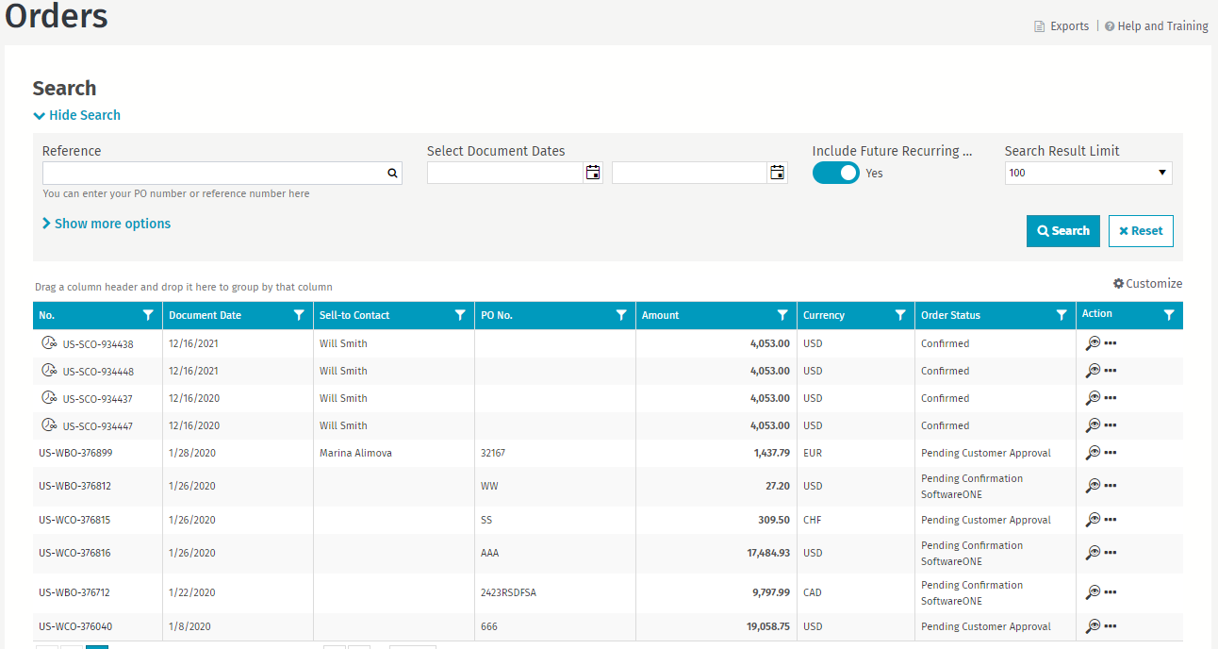
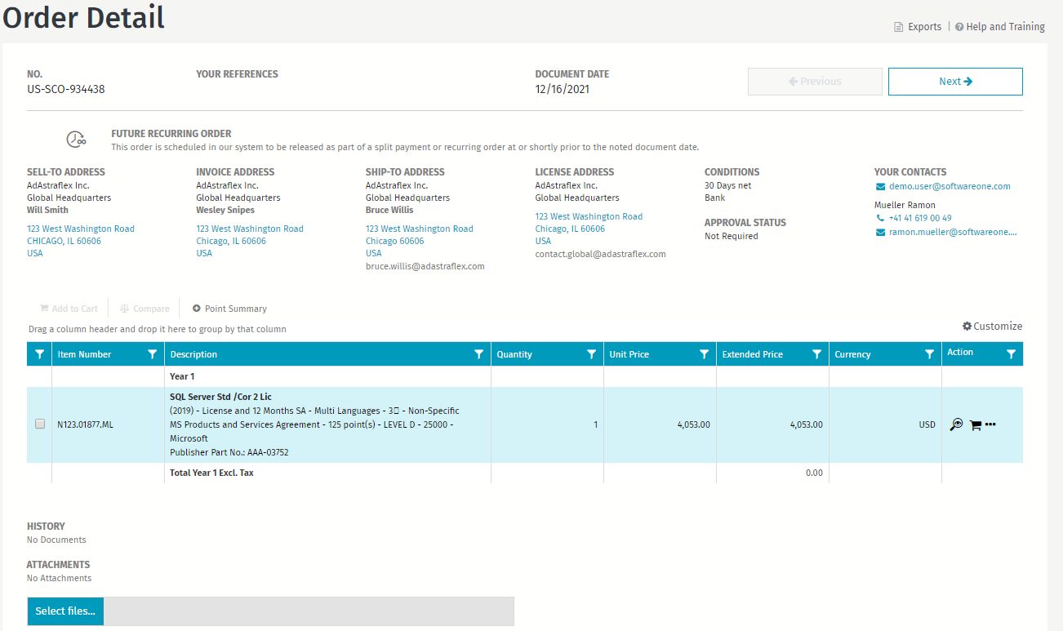
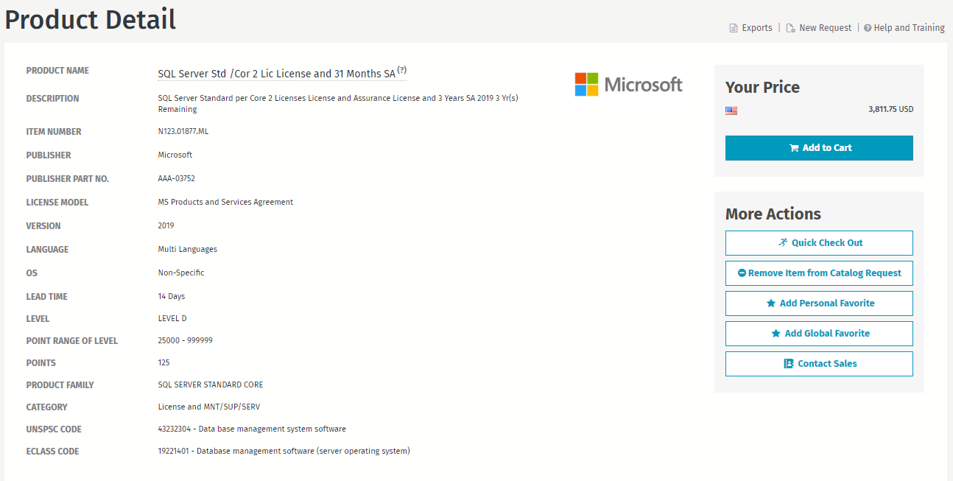
Products & search
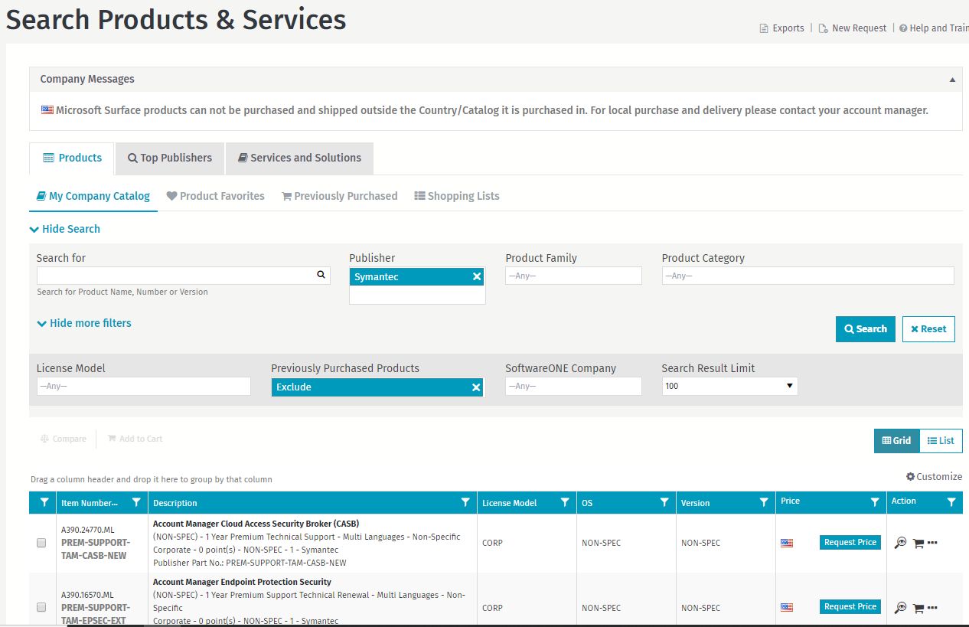
Invoices
Use of color codings for status (green , orange, red)
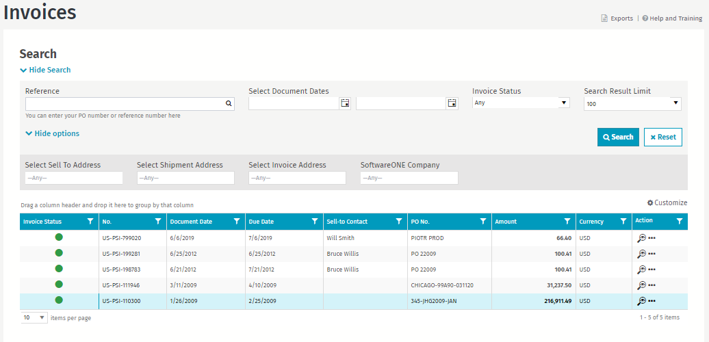
Invoice detail
History trail (quote/order/shipment,…) is also accessible
Idea: can we add all support cases linked to invoice/order -> warranty check? Does it makes sense to create a icon/function for warranty check? For example on overview of products bought and an indication if still in warranty or not?
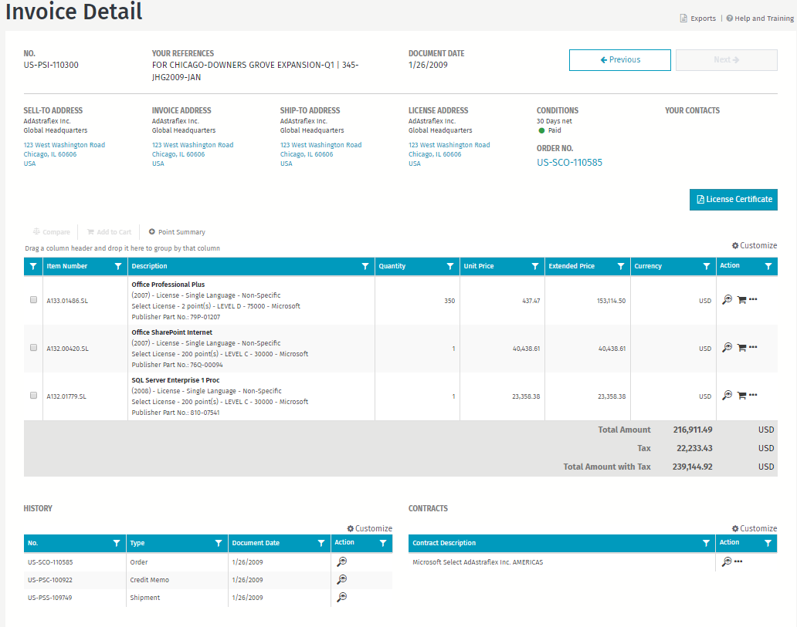

Voorbeeld Wizard (eventueel voor phased projects)
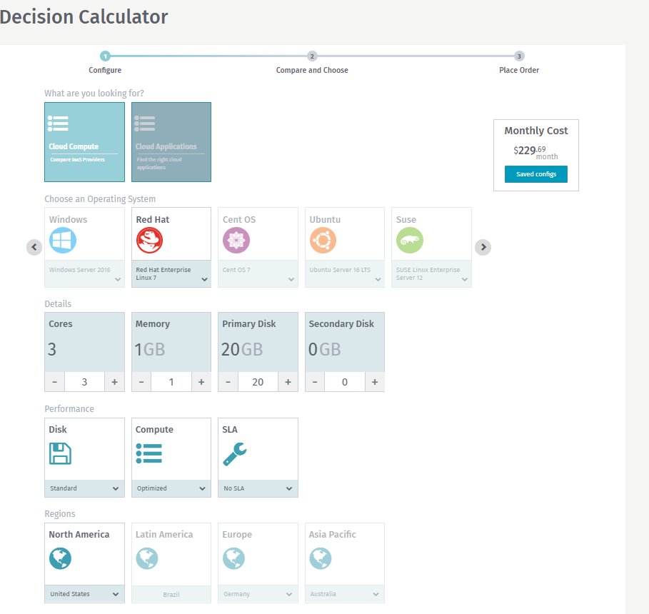

Edit Dashboards
The dashboard is build up by “Tiles”
Each Tile represents a certain KPI , summary, report, links, menu chortcuts.
You create a dashboard by adding the tiles to your canvas.
Within the canvas the tiles can be configured (ex: invoice period displayed, color, logo, ….)
The tiles can be rearranged by dragging and dropping in the canvas.

(Check Plecto.com)

